Methods name are:

Ancestor--- ancestor

---ancestor-or-self

Descendent--- descendant

Descendant-or-self

Sibling preceding-sibling

Following-sibling

Parent parent

Child child

Syntax:

/axesMethodName::tagname

url used <https://www.hyrtutorials.com/p/add-padding-to-containers.html>

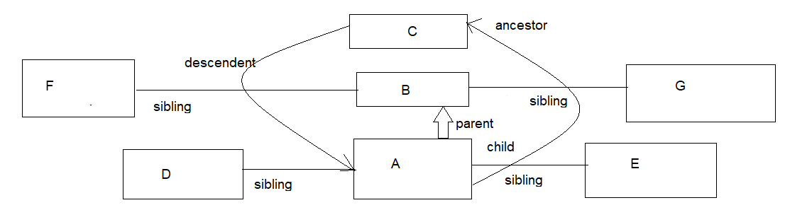

1. following-sibling :

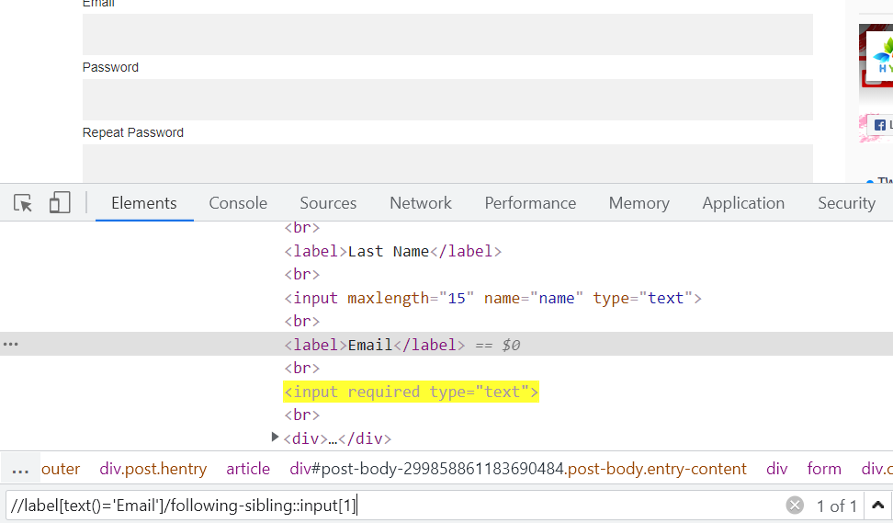

ii. preceding-sibling method:

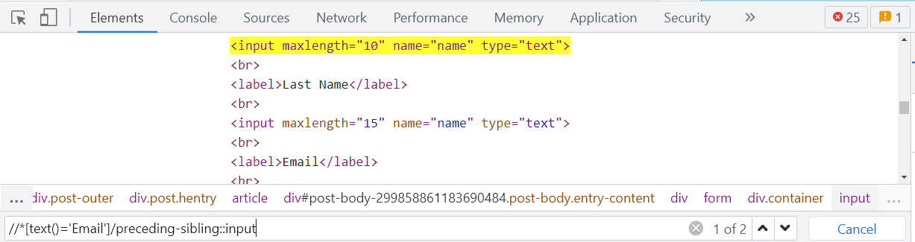

2. parent method:

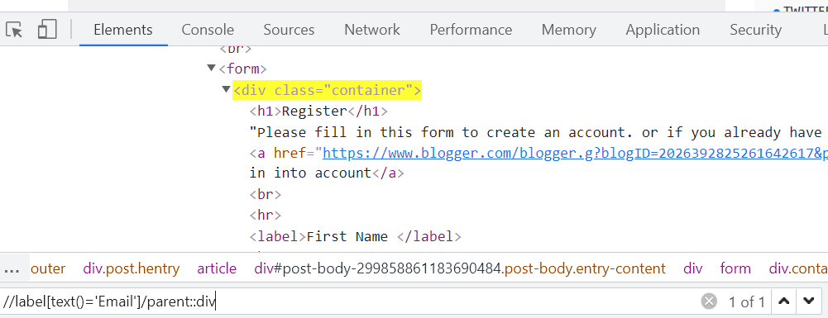 or can be

//label[text()='Email']/following-sibling::input[1]/parent::div

3. child:

//div[@class='container']/child::input[@type='text']

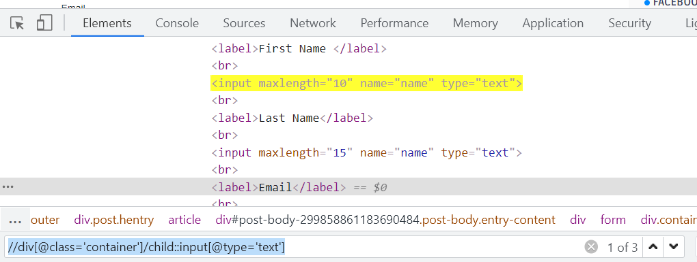

4. preceding-sibling:

//\*[text()='Alice Duval']/preceding-sibling::td/child::input

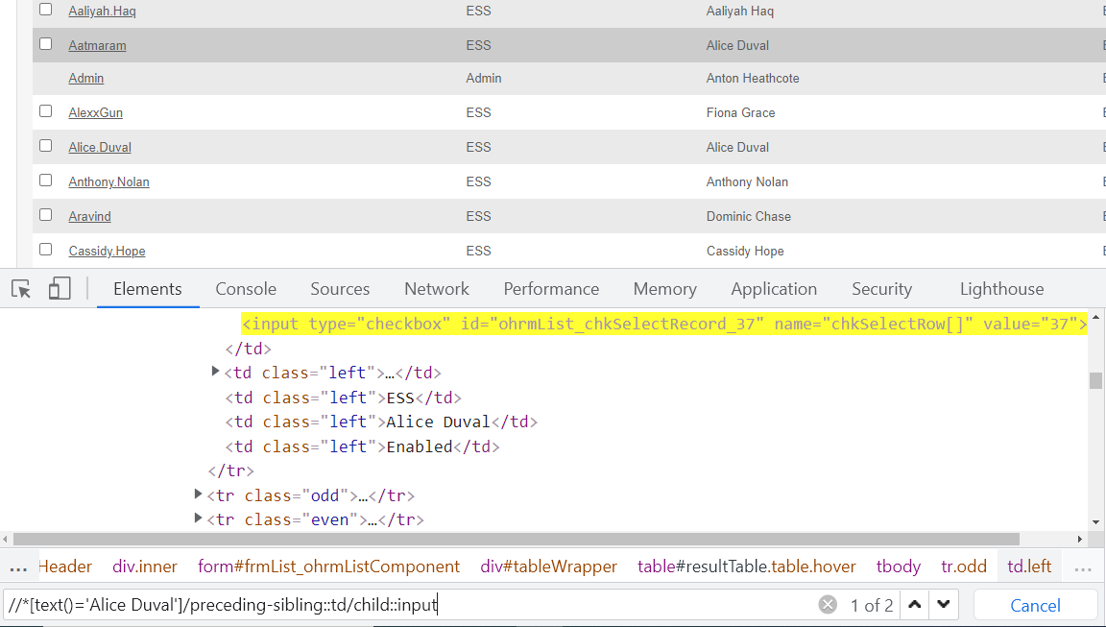

5. Descendant: To locate the grand children:

//div[@class='main section']/descendant::article

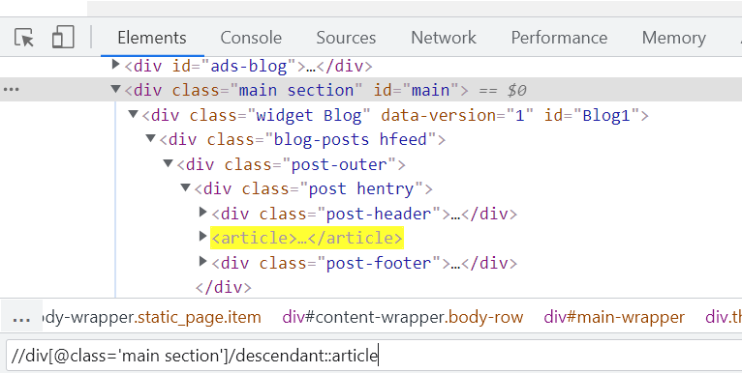

6. Ancestor:

//div[@class='main section']/ancestor::div

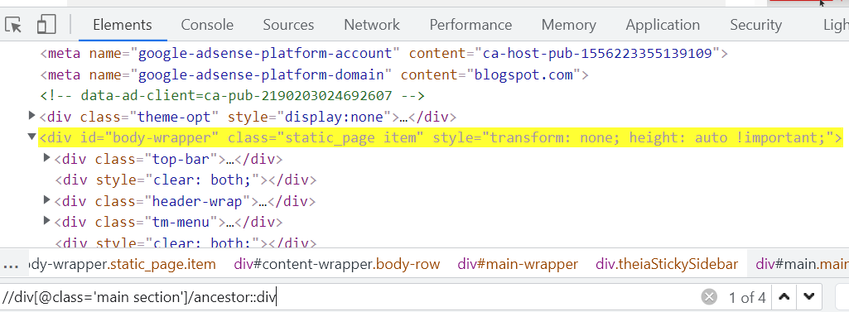

7. ancestor-or-self method:

//div[@class='main section']/ancestor-or-self::div

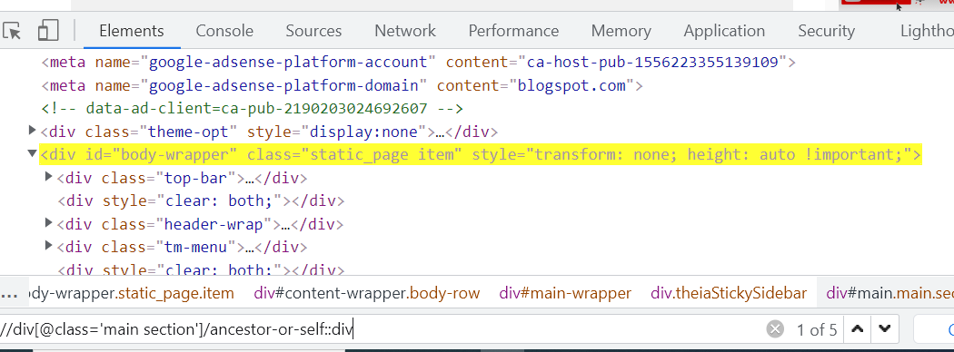

Like wise we have descendent –or-self , following and preceding methods.

CSS Selector:

id

Xpath: //tagname[@id=’value’]

CSS: tagname#value

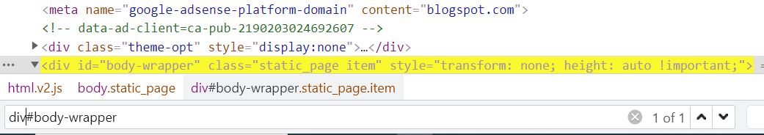

Class:

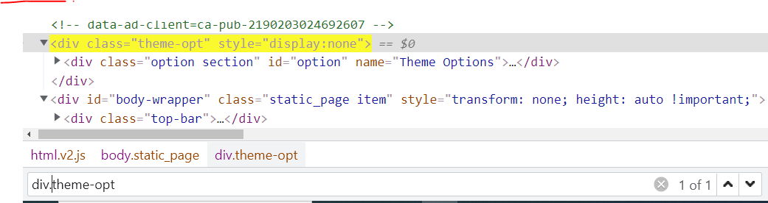

Xpath: //div[@class=’theme-opt]

CSS: div.theme-opt

Parent to child traversing:

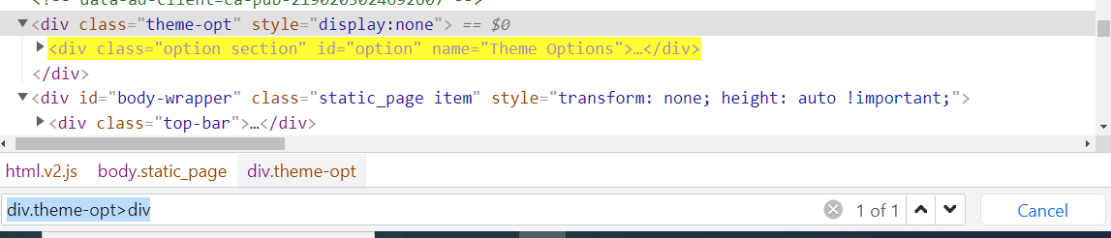

Xpath: //div[@class='theme-opt']//div

CSS: div.theme-opt>div

Some valid CSS:

input[type=checkbox]

or

[type=checkbox]

Starts with in CSS

input[type^=ch]

ends with in CSS

input[type$=box]

Difference between CSS and Xpath:

1. CSS expression is compact as compared to xpath hence it doesn’t take more time to evaluate.

2. In CSS there is direct location of that element irrespective to the xpath where we have so many relationship that come in the form of parent to child traversing. Hence CSS is much faster than Xpath.

3. More customization options are available in Xpath as compare to CSS.

Xpath with Logical AND and OR Operator:

1. AND: This matches the node only when both the attributes are matched inside the node.

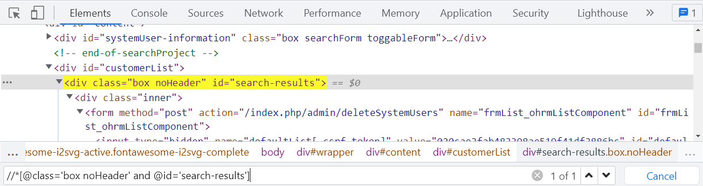

2. OR: This matches the node when any one of the attributes are matched inside the node.

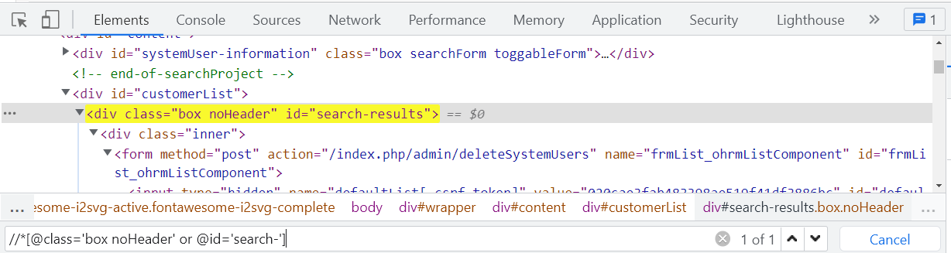

Git

Collection

String

Automation day to day- Jenkins

Saturday:- Git - 2 hrs – 7 :00 AM --

Sunday : Collection – 2 hrs – 8 AM to 10 AM & String practice session

Monday: Automation: 10 AM

Tues: JIRA : 7AM